Write a program of crypt arithmetic using python code

Aim :To solve a Cryptarithmetic problem using Python .

Procedure:
Assign digits to letters.
Ensure each letter has a unique digit.
Check whether the arithmetic equation is satisfied.
Display the valid solution.

Output:
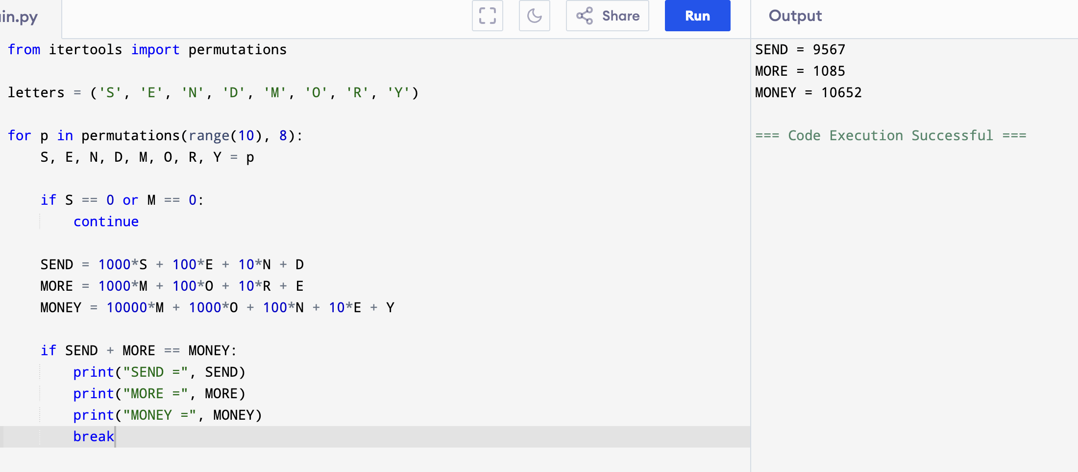

Result: Hence, crypt arithmetic problem has solved

